ISRGC26 – Competition Gear:

Polo Shirts
T-Shirts
Long Sleeve T (ideal for the glider pilot)

Polo Shirts (Pro RTX RX101 & RX101F)

Logo (front breast)
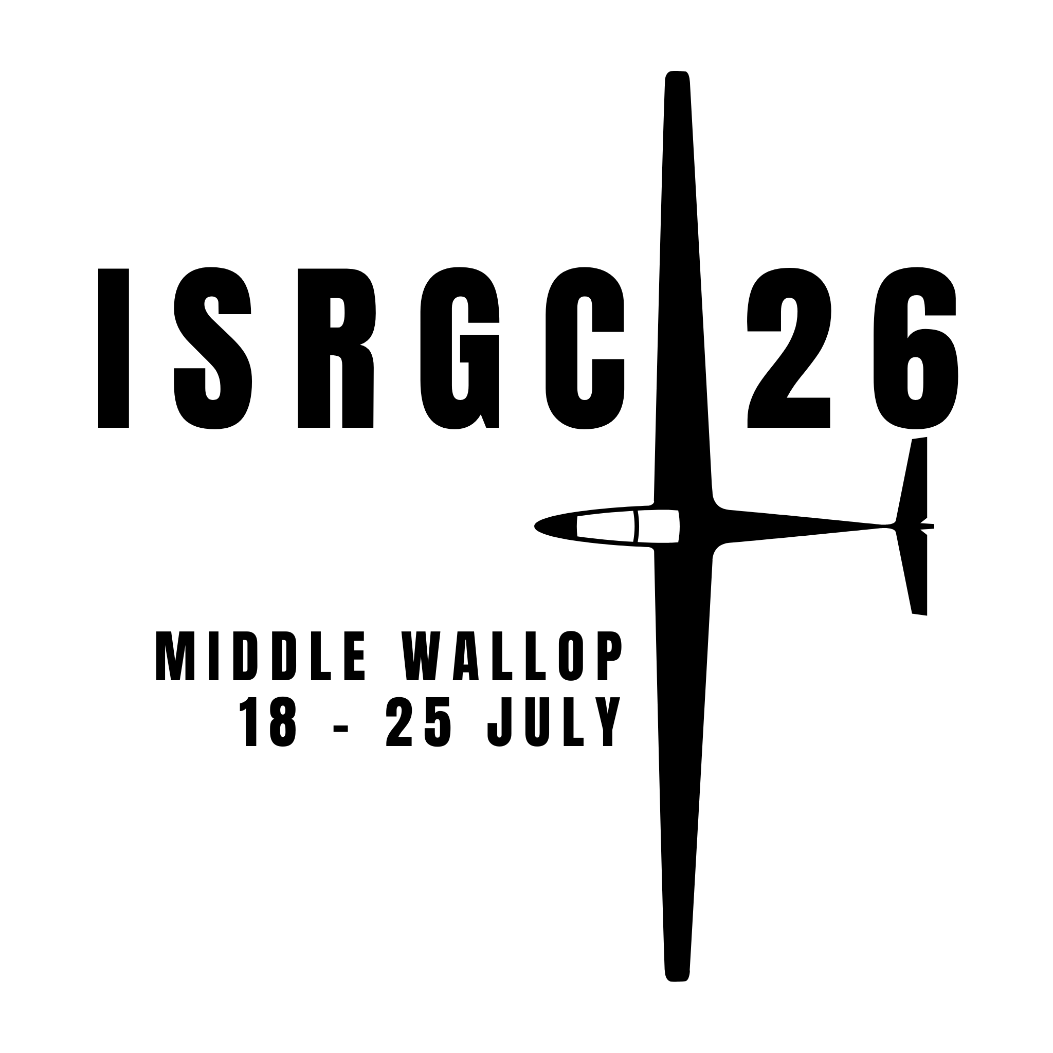

Colours

Black
Solid Grey
Burgundy
Purple
Royal Blue
Red
Sky Blue
Bottle Green

Sizing – Male

Size Guide
 | XS | S | M | L | XL | 2XL | 3XL | 4XL | 5XL | 6XL | 7XL | 8XL
 | 33/34" | 35/37" | 38/40" | 41/43" | 44/47" | 48/50" | 51/53" | 54/56" | 58/60" | 61/63" | 64/68" | 70/76"

Sizing – Female

Size Guide
 | XS | S | M | L | XL | XXL | 3XL | 4XL
Size | XS | S | M | L | XL | XXL | 3XL | 4XL
Ladies size | 8 | 10 | 12 | 14 | 16 | 18 | 20 | 22
Chest (to fit) | 30/32 | 32/34 | 34/38 | 38/42 | 42/44 | 44/48 | 48/50 | 50/52

T-Shirt (Gildan GD05)

Logo: Large screen print on back

Colours:

Black
White
Grey
Irish Green

Size Guide
 | S | M | L | XL | XXL | 3XL | 4XL | 5XL
Size | S | M | L | XL | XXL | 3XL | 4XL | 5XL
Chest (to fit) | 34/36 | 38/40 | 42/44 | 46/48 | 50/52 | 54/56 | 58/60 | 62/64

Long Sleeve T-Shirt (Gildan GD14)

Logo(as above): Large screen print on back

Colours:

Black
White
Grey
Irish Green

Size Guide
 | S | M | L | XL | XXL
Size | S | M | L | XL | XXL
Chest (to fit) | 34/36 | 38/40 | 42/44 | 46/48 | 50/52

